|  |
| --- |
|  |
| BOXiK |
| Guide |
|  |
| **HenryFord/Ilia Mogilevsky** |
| **06/08/2013** |

|  |
| --- |
| ©HenryFord ©BOXiK 2013 Licensed under the Creative Commons Attribution-ShareAlike 3.0 Unported Creative Commons License  <http://creativecommons.org/licenses/by-sa/3.0/> |

Introduction 1

Prerequisites (WIP) 2

BOXIK 2

Remote Binding (WIP) 2

First time screen (WIP) 3

Setup your Content 3

Media-Manager 3

Movies 4

TV-Shows 8

Music 10

Advanced Library Configuration 12

Playlists and the Context Menu 14

Playlists 14

The Context Menu 17

Additional Settings 20

Library Settings 20

Customization 21

Skins 21

Setup additional Add-ons 23

# 

# Introduction

Don’t worry - this is going to be short: This guide was created after a lot of people complained that “getting into“ BOXIK was kind of difficult for them. Thus I decided to create this guide to help them – and because you are reading this I assume I’ll help you: Welcome to the BOXIK Guide.

At this point I also want to thank the community around the BOXIK and the projects which rose in the near context. Thanks go out to Team XBMC – For creating the XBMC that powers the BOXiK.

They put a lot of work into this and deserve to be appreciated.

Now – let’s get started, shall we?

# Prerequisites (WIP)

In ordert o fully utilize your BOXiK you will need a good internet connection - anything above ADSL is fine. The internet is used to gaher information about yor media such as movie thumbnails, actor information, etc and also will allow you to stream youtube and other apps available on BOXiK. You will also need to create a share folders where your movies/music/photo are so that BOXiK can access it and play them. Please see the following guides to do so:

Windows 8: <http://windows.microsoft.com/en-AU/windows-8/share-files-folders>

Mac OS: <http://support.apple.com/kb/HT1549?viewlocale=en_US>

If your media is on a USB drive you can plug it directly into BOXiK.

# BOXIK

Homepage: http://www.BOXiK.tv

## Remote Binding (WIP)

In order to control BOXIK properly, you should familiarize with the remote that it comes with. This will help you navigating through the BOXIK and using its functions. It is important to know that the BOXIK uses some remote keys differently in different areas( ie Home screen and movies screens). So if you are playing a video in full screen the button-mapping might change.

I will list the common, global commands:

|  |  |
| --- | --- |
| **Key** | **Action, Description** |
| O | Displays CPU usage and video diagnostic information |
| P | Play |
| Space | Pause |
| X | Stop |
| F | Fast Forward |
| R | Rewind |
| Left-arrow | Left |
| Right-arrow | Right |
| Up-arrow | Up |
| Down-arrow | Down |
| Page Up | Page Up |
| Page Down | Page Down |
| Return | Select |
| Backspace | Parent Directory (Step back) |
| Q | Current Queue |
| W | Mark file as Watched |
| M | Activate OSD Player Controls (while playing media) |
| S | Activate Shutdown Menu |
| Esc | Home menu |
| I | Media Info |
| C | Context Menu |
| Period | Skip Next |
| Comma | Skip Previous |
| Tab | Toggles full screen modes (either visualization or video playback) |
| Print Screen | Screenshot |
| Minus (-) | Volume Down |
| Plus (+) | Volume Up |
| Zero (0) | Number0 |
| One (1) | Number 1 |
| Two (2) | Number 2 |
| Three (3) | Number 3 |
| Four (4) | Number 4 |
| Five (5) | Number 5 |
| Six (6) | Number 6 |
| Seven (7) | Number 7 |
| Eight (8) | Number 8 |
| Nine (9) | Number 9 |
| End | Shutdown BOXIK |
| Z | Zoom |

## 

## First time screen (WIP)

When you power your BOXIK for the first time you will be greeted with the first time setup screen. This gives you shortcut options to setup up your BOXiK with your network, setup video source,

(screenshot)

At this stage please press on the network and make sure you have either “Wired” selected or if you want to use your wireless network please choose it from the list. Once that it done you can start adding your media sources – please see next section.

## Setup your Content

Sources - this is where BOXIK looks for your media-files. The Sources will determine the content of your library, they are necessary in order for BOXIK to index your Music-/Video-Files into the proper libraries. Be aware that you always should name your video- and music-sources according to BOXIK’s set (more on this beneath). This will make sure that you have the best possible experience with BOXIK. Let’s get started.

### Media-Manager

Before we are adding your files to BOXIK, we should make sure that the files are named properly. Ideally you have your movie-files all in one folder. It does not matter if there are subfolders and/or single files in this directory. The best way however is to use subfolders for each movie you have. The folder should then be named according to the following Layout: “Movie Name (Release-Year)”. The part “Release Year” is technically not necessary but it will make sure that BOXIK scrapes the right movie and you have the right movie in your library. If you currently have not sorted your movie-directory, you can do this with the help of some additional tools which are available. Some free tools:

#### Multiplatform

* UniversalMC - [sourceforge.net](http://sourceforge.net/projects/universalmc/)
* Media Reader - [forum.xbmc.org](http://forum.xbmc.org/showthread.php?t=49370)
* Mythical Librarian - [wiki.xbmc.org](http://wiki.xbmc.org/?title=MythicalLibrarian) (for Myth TV-Recordings)

##### Windows

* XBNE - [forum.xbmc.org](http://forum.xbmc.org/showthread.php?t=59800)
* Media Companion - <http://mediacompanion.codeplex.com/>
* XMM2 - [plyoung.com](http://www.plyoung.com/projects/xmm2/)
* Ember Media Manager - [sourceforge.net](http://sourceforge.net/projects/emm-r/)

##### Mac OS X

* ViMediaManager **-** [forum.xbmc.org](http://forum.xbmc.org/showthread.php?p=886768)

These tools will generate usable NFO-Files for the BOXIK. NFO-Files are little text-files in which all information about the movie is stored. If BOXIK finds a NFO-File inside a subfolder, it will use the information from this NFO rather than downloading the information from the internet. For some more information on NFO-Files head down, you’ll find a section dedicated to them. A neat function of the BOXIK provides the possibility to play two video-files as if they are merged to one file. This is helpful for movies which contain multiple CDs. If you have the movie “The Matrix” for example split into two files, you should name those files like “The Matrix.CD1.FileExtension” and “The Matrix.CD2.FileExtension” (this will be done by the media managers mentioned above as well). When scraping this movie to the library, BOXIK will know that this is supposed to be one movie and will index the both files only as one movie in your library. If you then play this movie via the library in your BOXIK both files will be played – the CD2 after CD1 ends – seamlessly. You won’t even notice the cut between those (unless the files have an overlay of course) two.

### Movies

To start adding a source for movies, hit the “Videos” button in the Home-menu (the screen you are welcomed with after starting BOXIK). If this is the first time you’re accessing a menu, you will be presented with the following help screen:

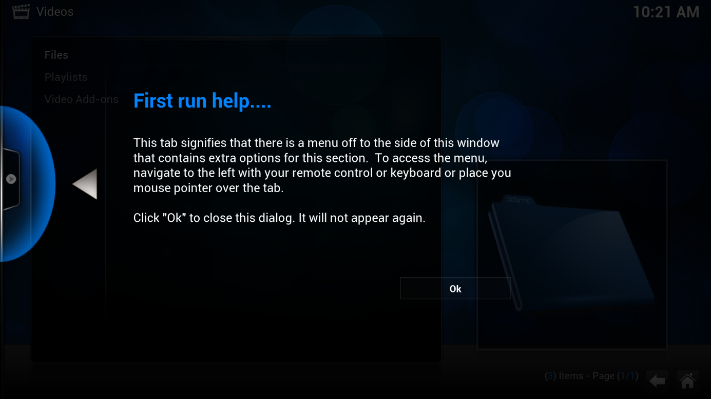

#### Setup the Sources

Hit “OK” to continue (make sure you read what the screen tells you though). You’re now accessing the top of the videos-tree, select “Add Videos…” in the following screen. You then will be presented with the “Add Source”-Screen:

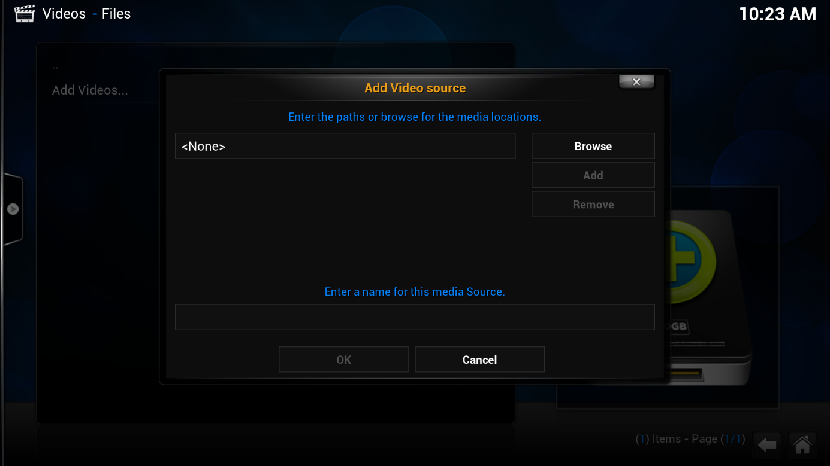

Hit the “Browse”-Button and locate your movie-location. Select “Windows Network”, select “Workgroup” and navigate to the shared folder of your movies or tv shows

TIP: If you don’t see your computer or your shared folder please unsure you have shared it correctly – pleasee see prerequisites on page 1 of this document

Once you located the folder, select it to open it and navigate to the OK button below it. Once selected you will be presented with a “Set Content” screen - it will look like this.

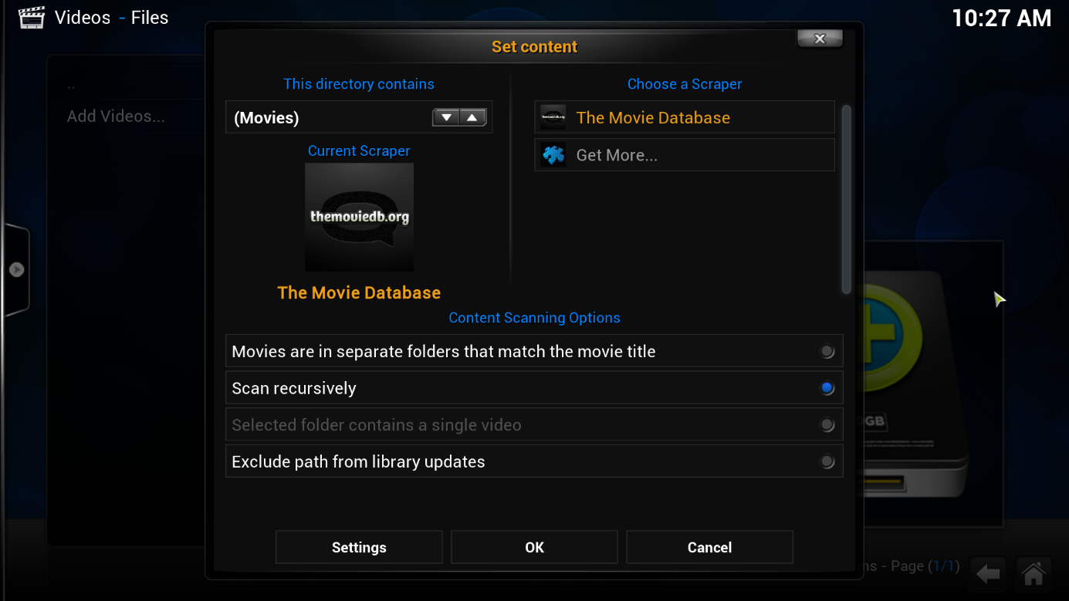

This setup depends on how your movies are setup. Most of the management-programs listed in the first section will be using separate folders for your movies. This means that you have one root folder (for example “D:\Movies”) in which you have subfolders for every single movie you have (for example “D:\Movies\Lord.Of.The.Rings.-.The.Fellowship.of.the.Ring.(2001)”). In this case activate the radio-button next to “Movies are in separate folders that match the movie name”.

After you hit “OK” you will be asked if you want to refresh all item in the path. Press “Yes” here in order to catalogue your movies right now.

#### The Library

Once you have scanned in your movies, you can use the library-section of BOXIK. Head back to the Home-Menu and click on the new item “Movies”. You will be presented with a screen similar to this (except, of course, that you will see all of your movies instead):

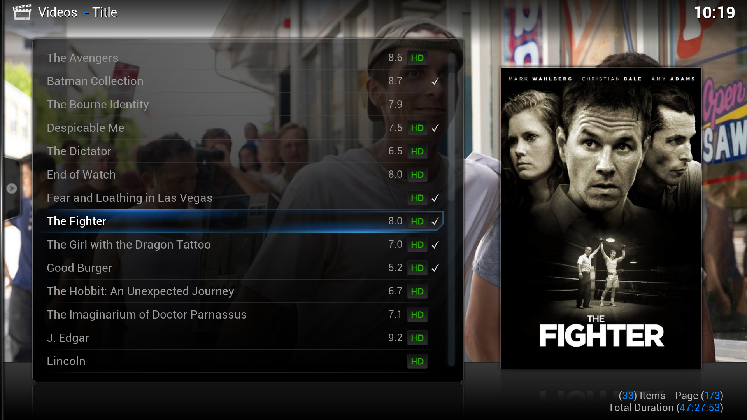

#### The Library Views

You can now customize this screen the way you like it. You can choose different layouts and different layers of information. Where you see only the poster, the fan art and the movie name in the first screenshot, check out this one, where you can also see the information about the Genre, Length, Rating, Story, etc.:

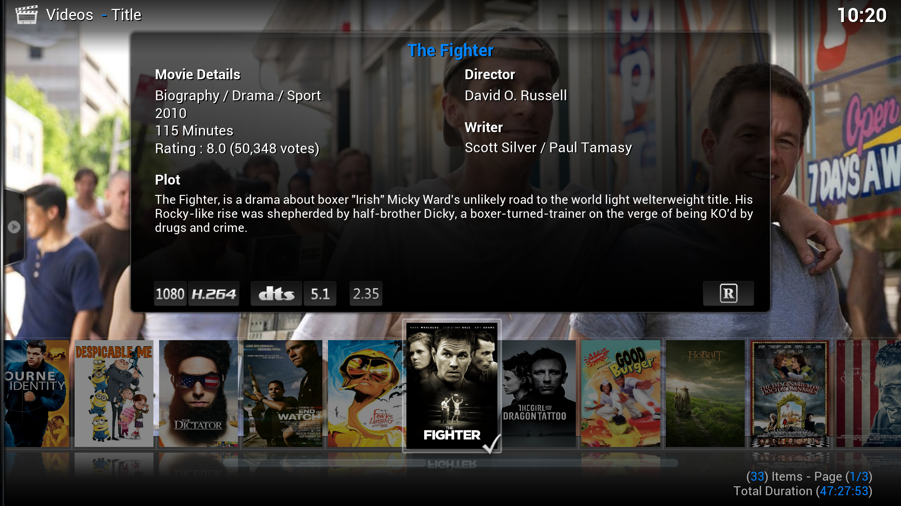

You can change the layout of the view by hovering on the little arrow on the left side – another menu will open where you can choose which layout you want:

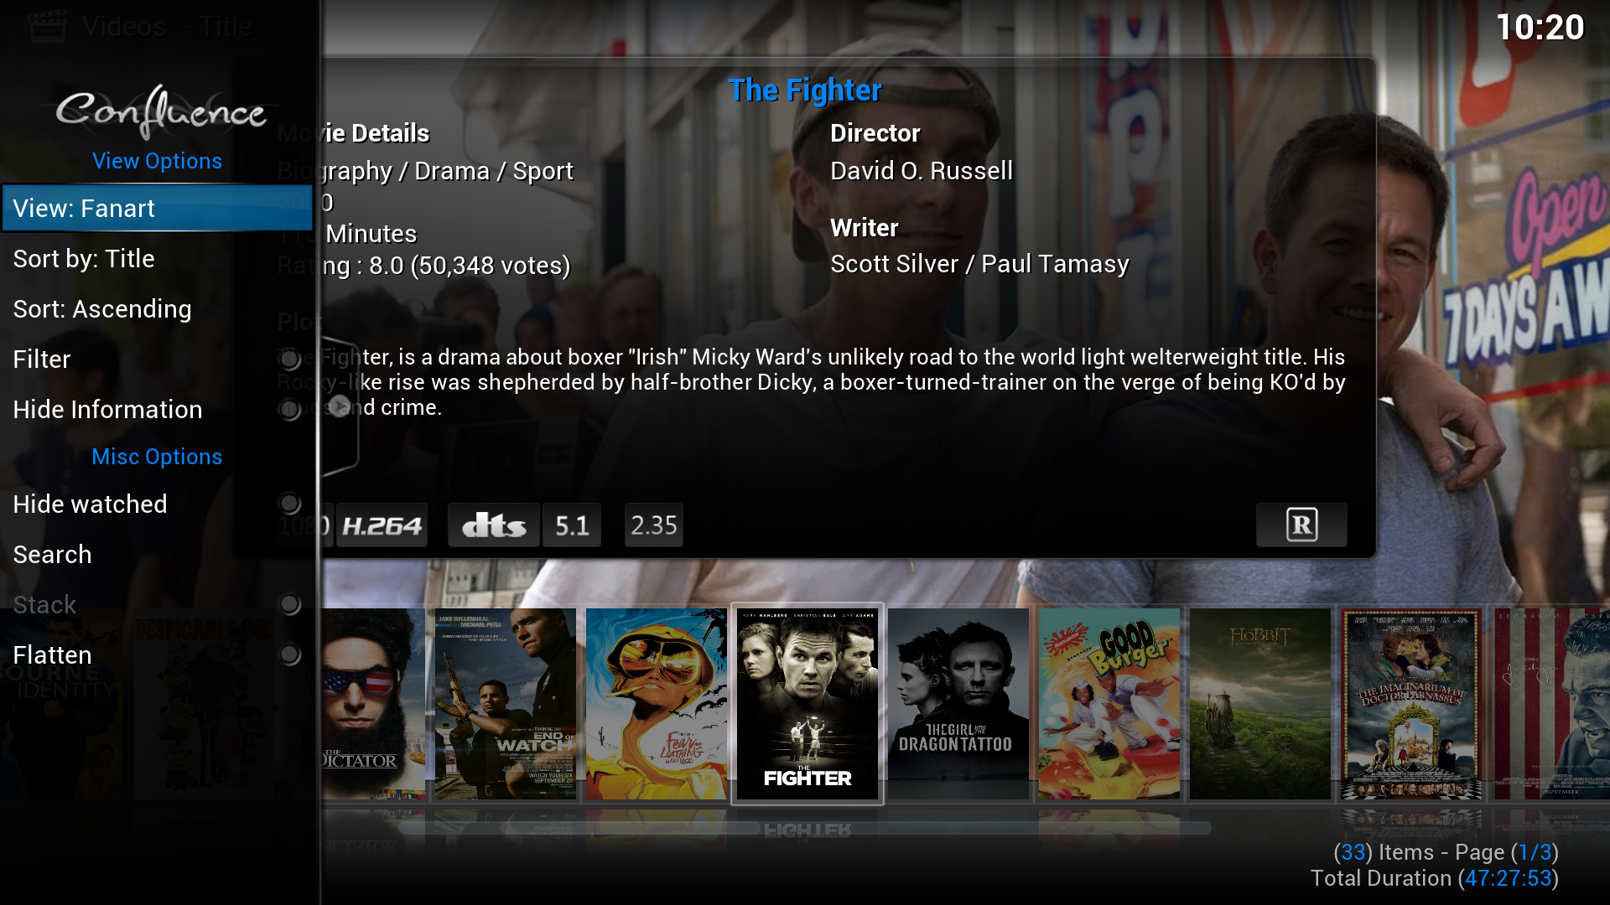

### TV-Shows

#### Setup Sources

With TV-Shows you also have the option to use locally stored NFO-Files for BOXIK. In this case BOXIK will also use the provided information in the NFO-Files to check for your TV Shows. This will make sure that you do not have problems with the scanning. Be aware that you should apply the naming-convention “TV-Show-Name (Starting-Year)” to the subfolders holding your TV-Shows. This will make sure that you do not get the wrong information.

Now head back to the BOXIK, click on “Videos”, select “Add Videos”. Select your TV-Show-Directory and click OK. In the “Content”-Screen you should then select “TV Shows”. If you want to add everything right now, simply click on “Yes” after you hit “OK”.

#### The Library

You can now use the TV-Show library as well. Head back to the Home-Screen and click on the new button “TV Shows”. You will be presented with a screen similar to this (except you’ll see your shows, of course):

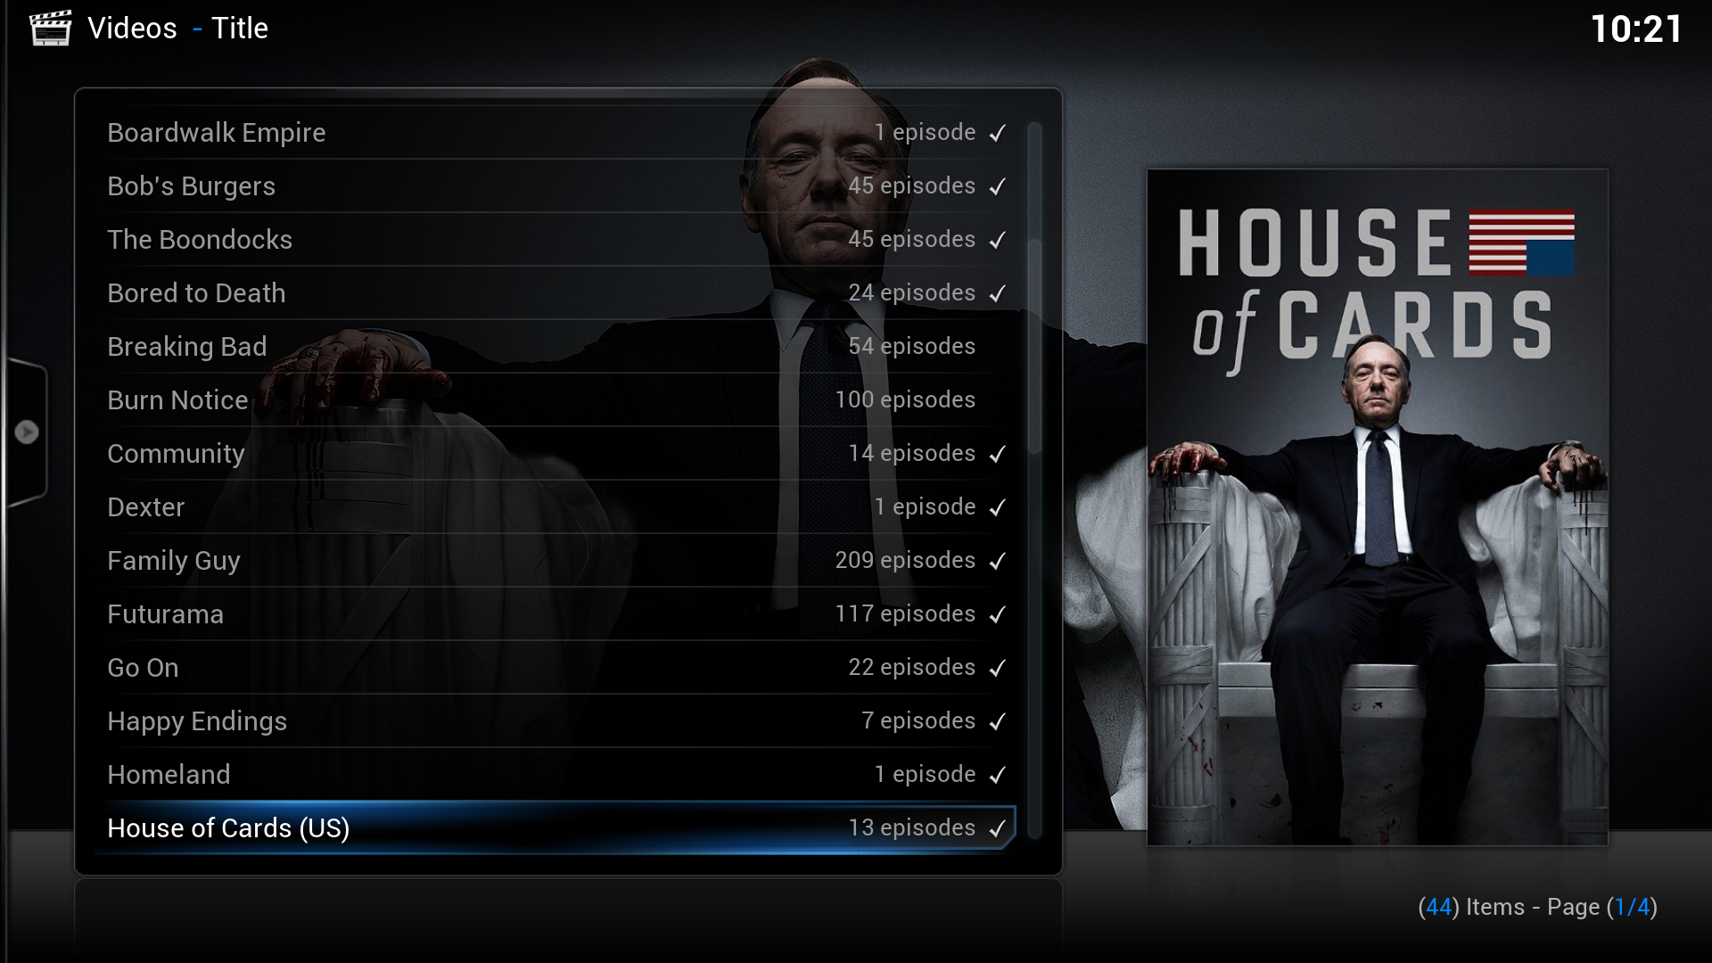

If you click on one of the titles of your shows, you can select an episode you want to watch.

#### The Library Views

As with movies, the TV Show library has different views from which you can choose. Above you see only the poster, title and the fan art. But you can choose to display even more information – one special addition can be applied to the TV Show library: Episodic views. For example, below you’ll find screens which display more information – first for the TV Shows and then for the episodes:

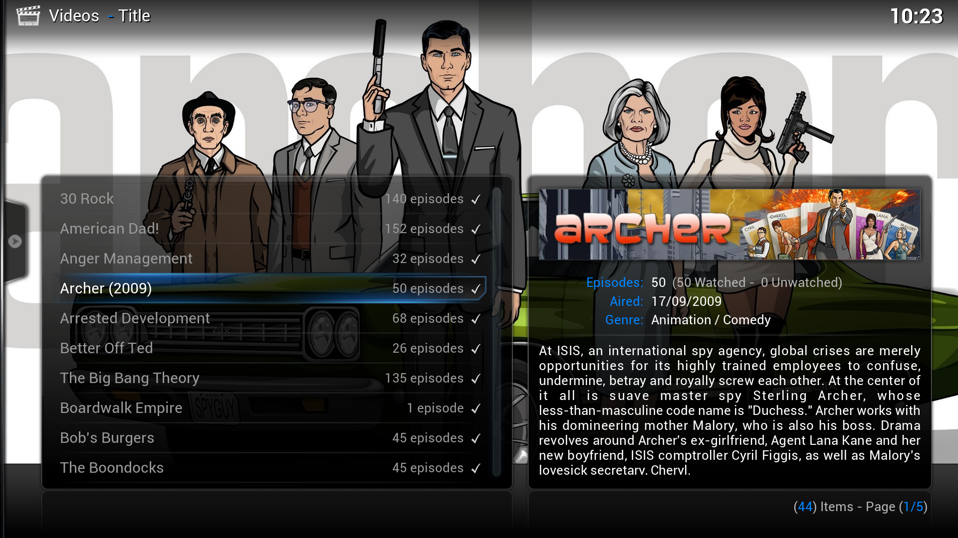

If the TV Show you have collected has multiple seasons, you can also choose a special view for the single seasons. The resulting structure in BOXIK is as following:  
Home-Screen 🡪 TV Show (🡪 Seasons) 🡪Episodes

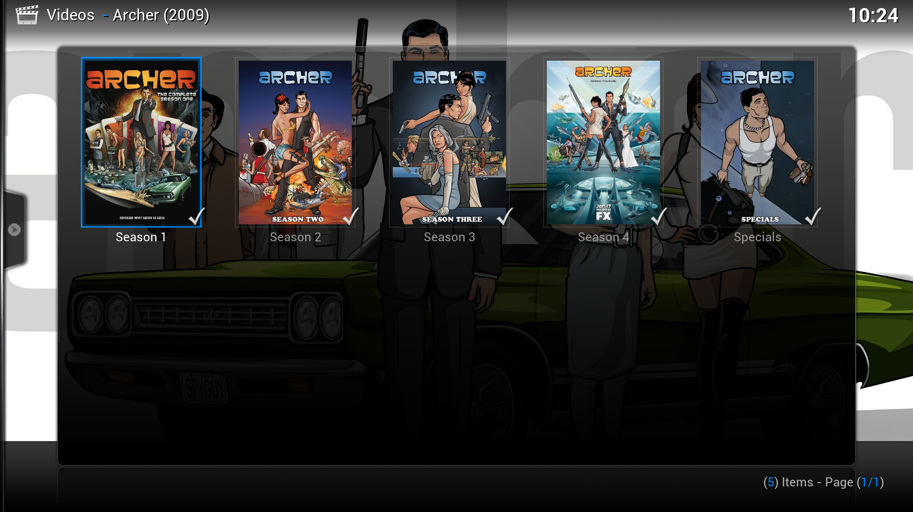

### Music

BOXIK can also maintain your music library. In this case it is best to have the Tags setup properly. You can set the tags with the help of a few programs, on freely available open-source tool is “Musicbrainz Picard”.

#### Setup the Sources

To start adding Music to your BOXIK, you have to choose between file or library mode. In either case you have to add a source first. Head to the home-screen of BOXIK and click on “Music” and then “Add Source”. Choose the directory where you store your music and click on OK. Now you have to choose what you want.

#### The File Mode

The File Mode does not require any additional setup from this point on. Just click on the source and choose the music you want to play. You can add whole directories to the queue by opening the context menu (see section [The Context Menu](#_The_Context_Menu)).

#### The Library Mode

In this mode you have a library similar to the one of TV Shows and Movies. Your content will be scanned to the library and will be used with additional information to provide the best experience to you. To start using the library you have to scan the items to the library. Select the source of your music and open the context menu (usually by pressing “c”) and click on “Scan item to library”. This will induce BOXIK to scan all content in the folder against the default scraper to your library. This can take a while if your library is big. After the process is finished bring up the right handed side-menu by hovering over it or pressing the UP-Arrow on your keyboard (assuming default settings) – here choose the entry “Library Mode”:

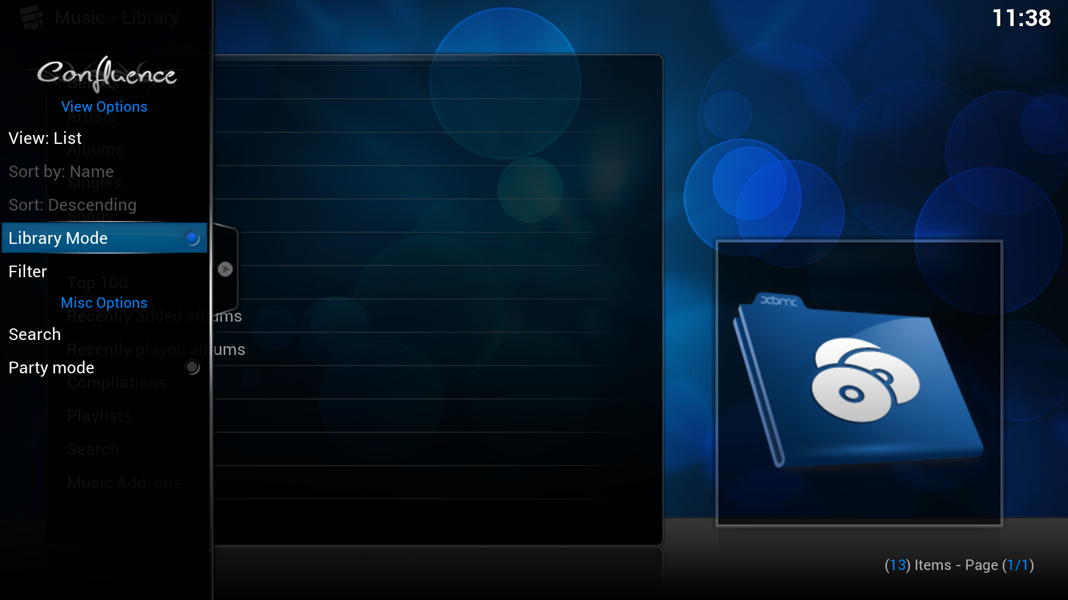

#### The Library/File Views

Now you can navigate your music by using different views and categories. You can for example choose to browser your music by Artist, Genre, Songs, etc. (assuming you are using library mode at this point)

You can also apply different views to nearly every single page in the music library. Here for instance is a view of the albums (those views can also be applied to the file mode – but not as versatile):

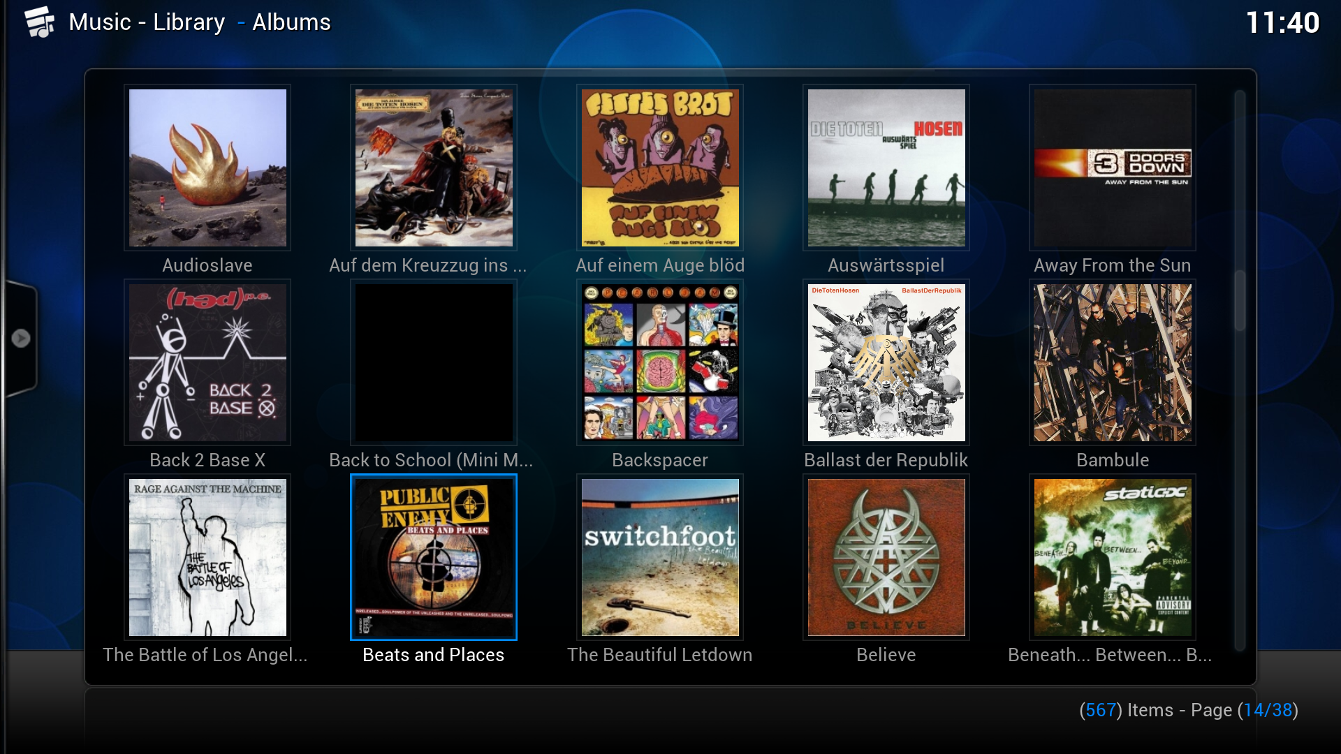

### Advanced Library Configuration

#### Movie Sets

In BOXIK Eden you have the possibility to easily group movies into sets. You may now the problem that you have a collection of movies from the same set, but they don’t sort like you wanted. Another possible application is when you simply want a Movie-Set to be displayed as one entry in the Movie-Section. An example would be the “Lord of the Rings”-Trilogy. The movies included:

1. Lord of The Rings – The Fellowship of the Ring
2. Lord of the Rings – The Two Towers
3. Lord of the Rings – The Return of the King

You can now activate movie set grouping in the settings menu (Home-Screen -> Settings -> Videos -> Library -> “Group movies in sets”). This will cause BOXIK to display all those movies as one title in the library, opening it will list every movie of the set. Note that this will only work if you selected the “The MovieDB” scraper for your movie source. For every other scraper you will need to use NFO-Files in order to sort the movies into sets. For the example above, the line that should be added to the nfo-files of the movies which belong to the set:

*<set>Lord of the Rings Collection</set>*

Re-scrape the movies and they should display as one movie set in your library. See the example below – first the view upon the collection as a single title, then this collection opened up (note that the collection view can indeed have a own view set):

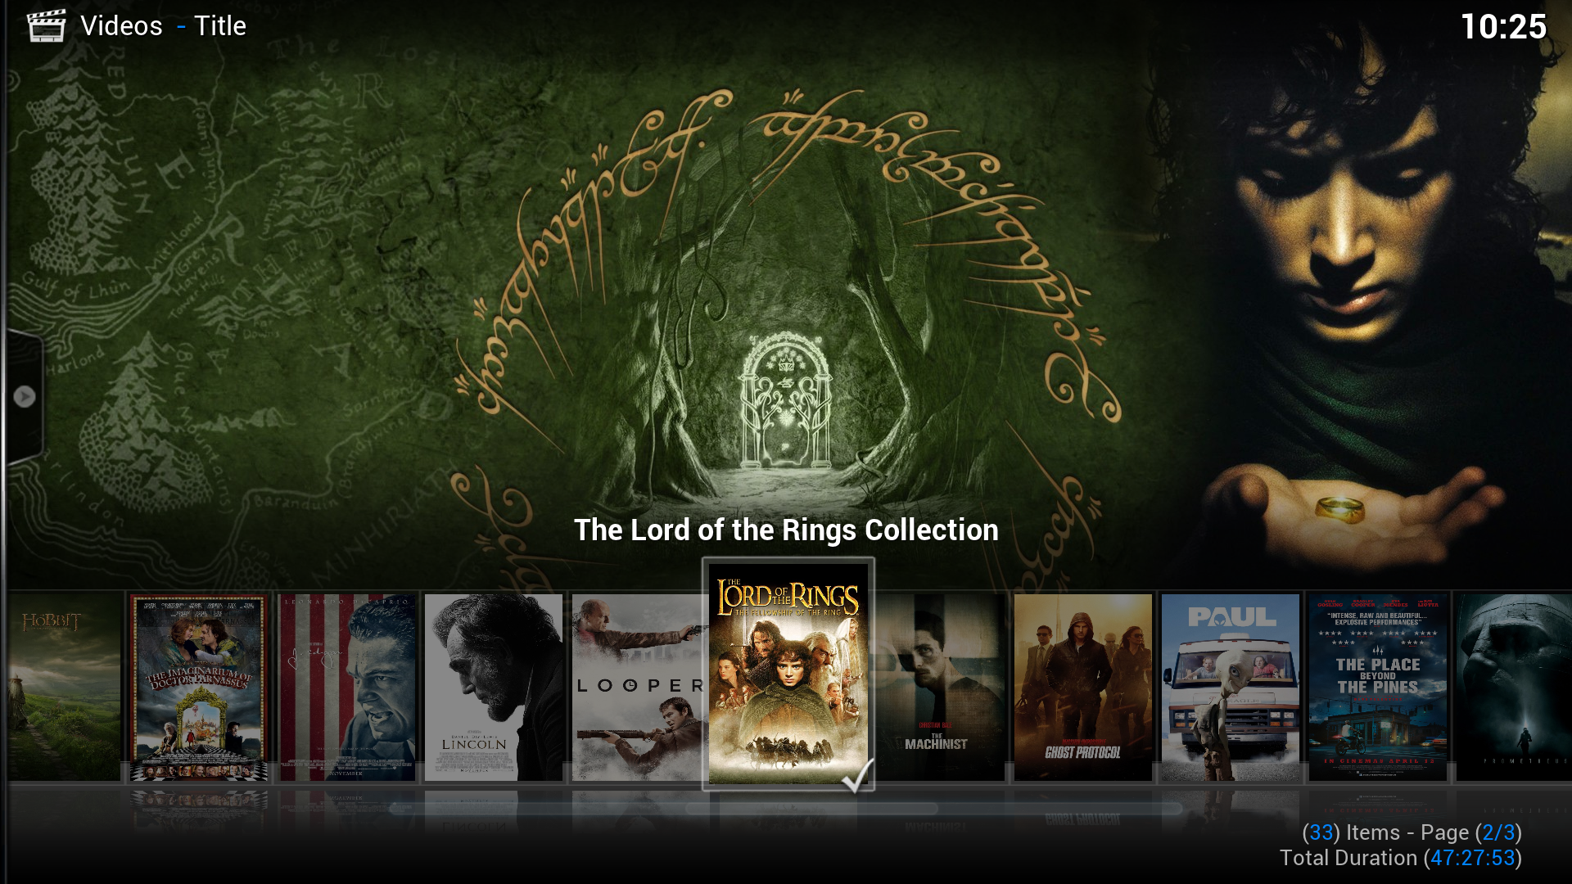

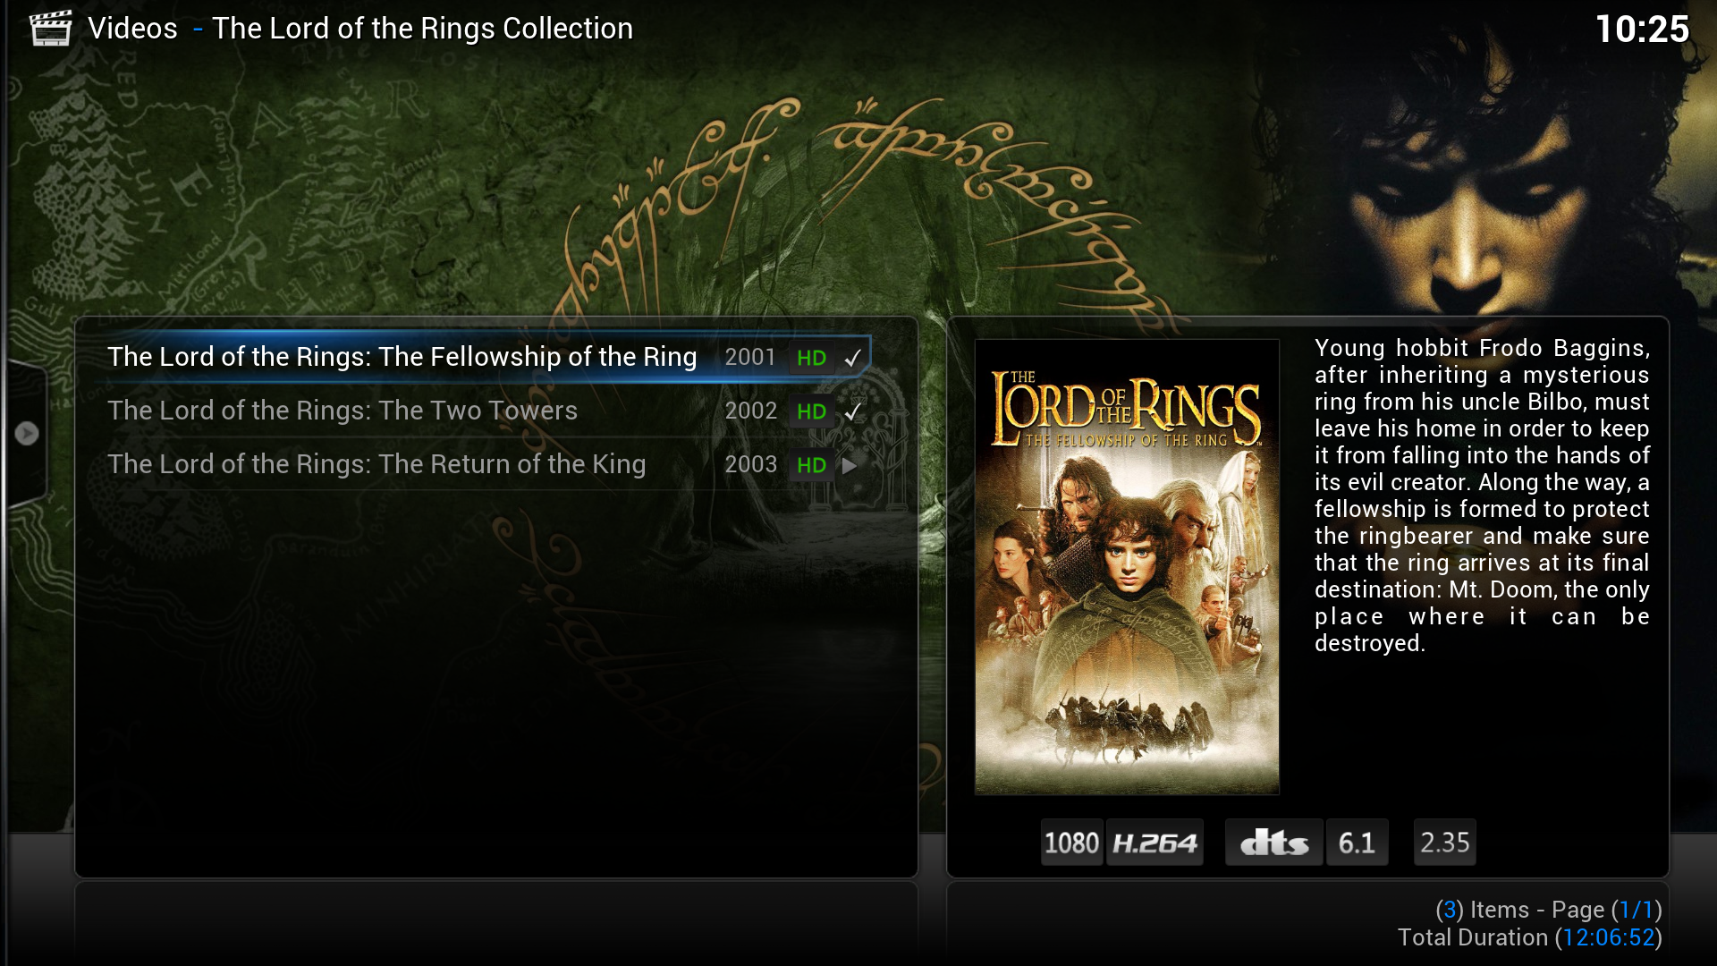

#### NFO-Files

NFO-Files can influence many aspects of BOXIK’s library. For more information visit the BOXIK-Wiki: [http://wiki.BOXiK.org/index.php?title...ining\_XML\_data](http://wiki.xbmc.org/index.php?title=Import_-_Export_Library" \l "Video_nfo_Files_containing_XML_data" \t "_blank)

#### Automatic cleaning of the library

If you delete a lot of movies/TV Shows after you have watched them, you will notice that the BOXIK will not clean these files if you launch the Library-Update. You can erase those movies only if you pick the “Clean Library”-Function in the settings-menu. Another solution however would be to put a file “advancedsettings.xml” into your BOXIK-Userdata-Folder. For Windows just hit “Windows-Key” + “R” and type “%AppData%/BOXIK/userdata”. Create a new text-file with the following content inside this directory:

*<advancedsettings>*

*<videolibrary>*

*<cleanonupdate>true</cleanonupdate>*

*</videolibrary>*

*</advancedsettings>*

Rename the file to “advancedsettings.xml” and restart your BOXIK. Your BOXIK will now clean your video-library every time it updates it.

Warning:  
You should be aware that cleaning your library may result in unexpected behavior. If your media-sources for example are located on an External Drive and you launch the cleaning while the drive is disconnected, your whole library will be erased! If the media somehow isn’t available, you are going to lose everything stored in the library.

#### AdvancedSettings.xml

You can do a lot more with the “advancedsettings.xml” – for more information check the BOXIK-Wiki:   
[http://wiki.BOXiK.org/index.php?title=Advancedsettings.xml](http://wiki.xbmc.org/index.php?title=Advancedsettings.xml)

## Playlists and the Context Menu

The Context Menu enables you to access many additional features of BOXIK, so I will present a few of them. In this section I will also introduce you to playlists, with which you can build special playlists for every occasion.

### Playlists

What are playlists? Playlists contain multiple items in a specified order, which then can be played by BOXIK in that same order. Playlist can be built from different settings, some of them statically, some of the dynamically. You could for example have a Playlist that features every item in your TV-Show library with the resolution 720p, but you could also have a playlist that is featured with every item of the genre “Action” and is at least 1h long. You can fully customize them for your needs.

#### Building a Playlist

In order to build a playlist, you first have to decide what type of playlist you want to build. I will introduce you to Video-Playlists, but Music-Playlists work essentially the same. First off, navigate to the Home-Menu and click on “Videos” and then on the entry “Playlists”. Now click on the entry “New Smart Playlist” and you will be presented with the following screen:

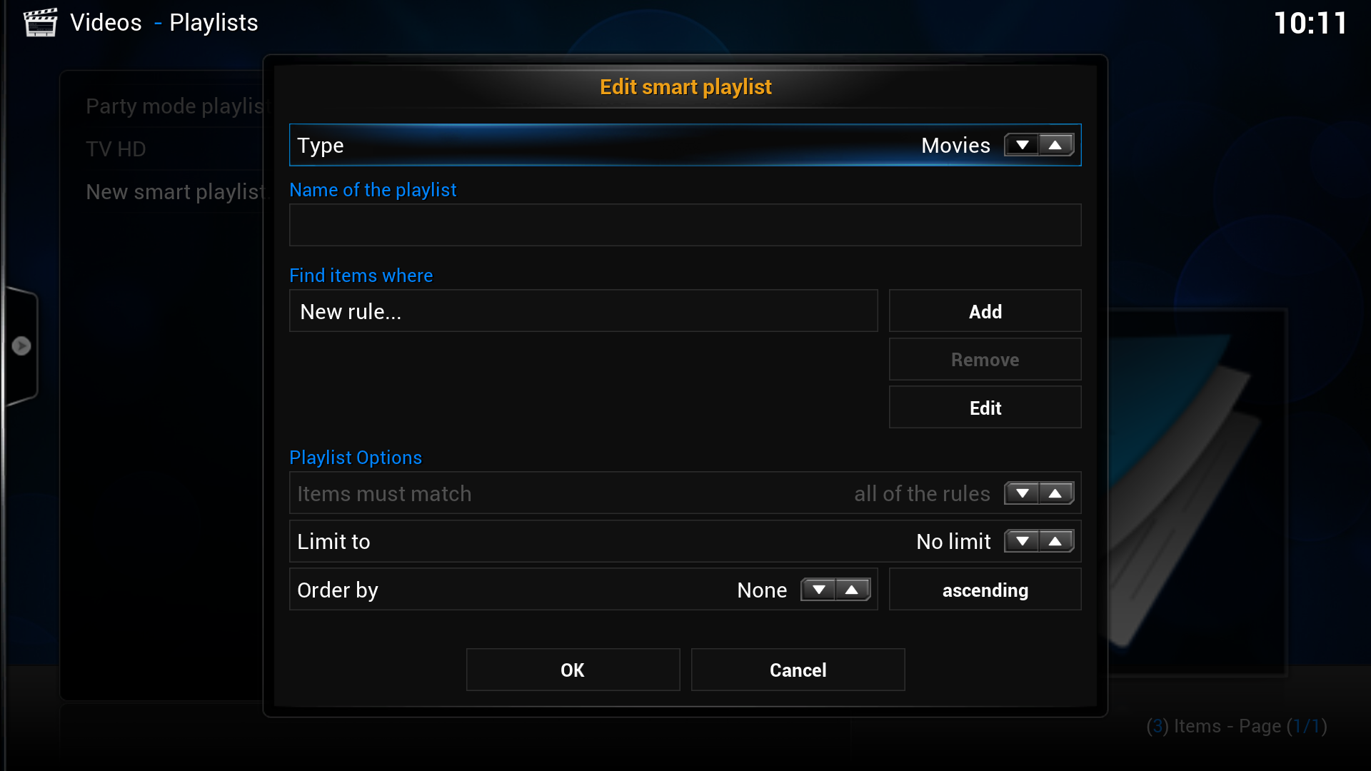

##### Example 1 - Movies that have at least 720p resolution

Setup:

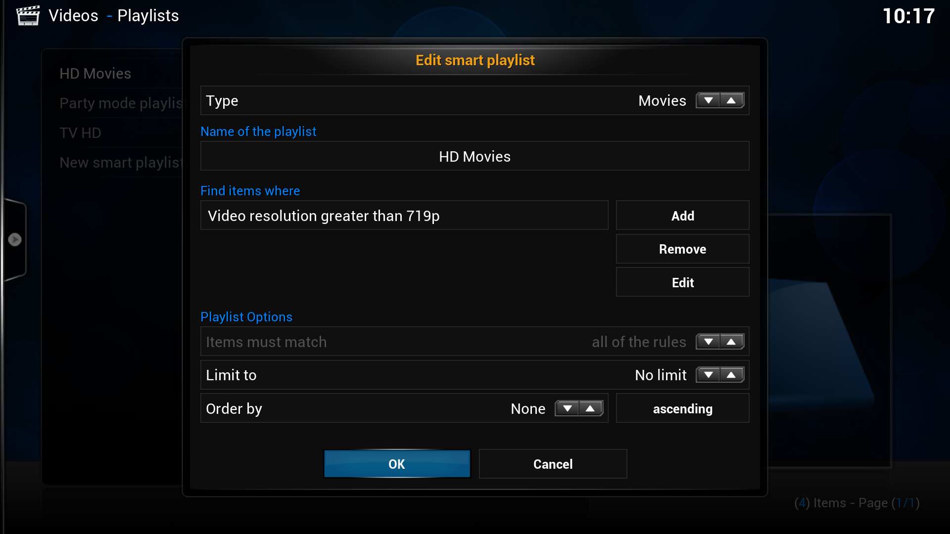

Result:

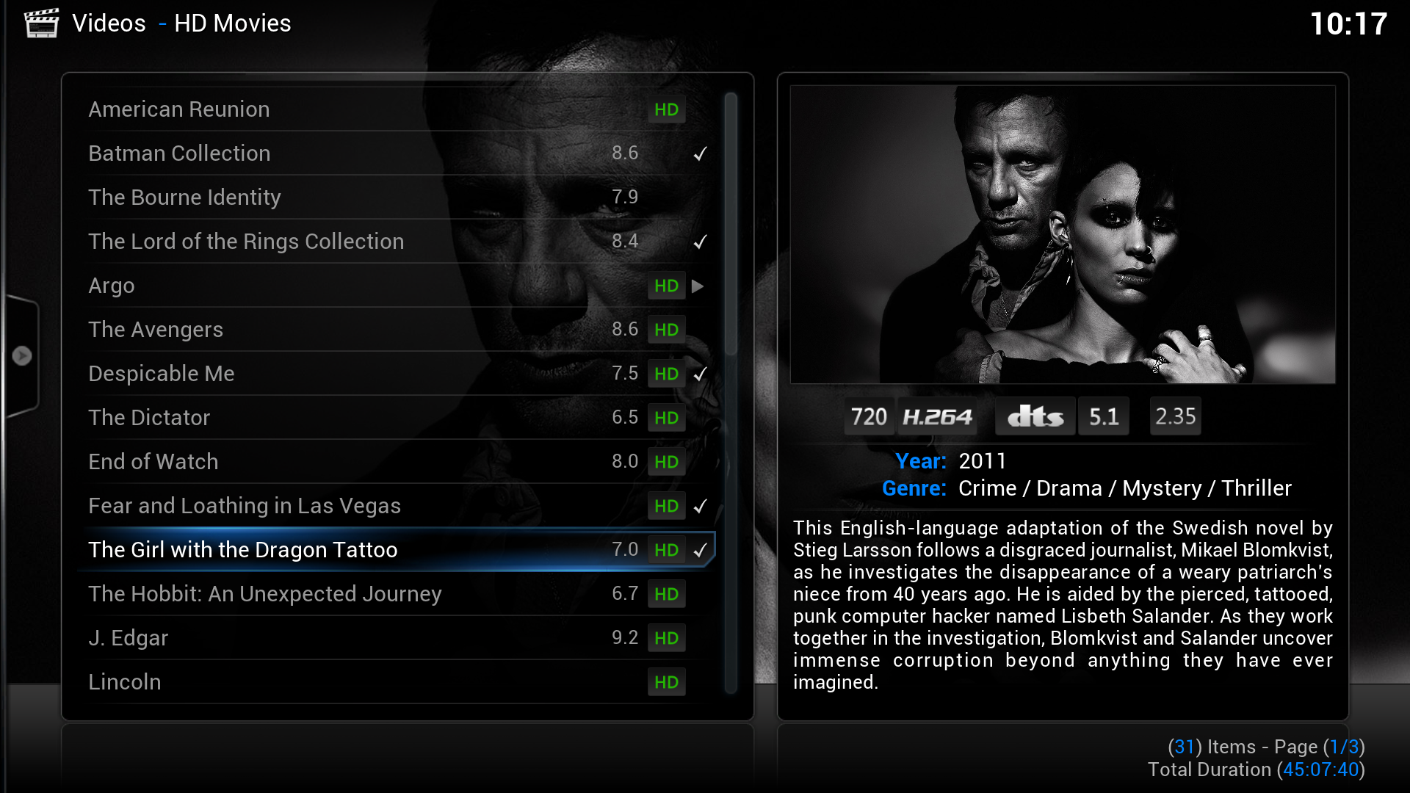

##### Example 2 – Unwatched TV-Show Episodes

Setup:  
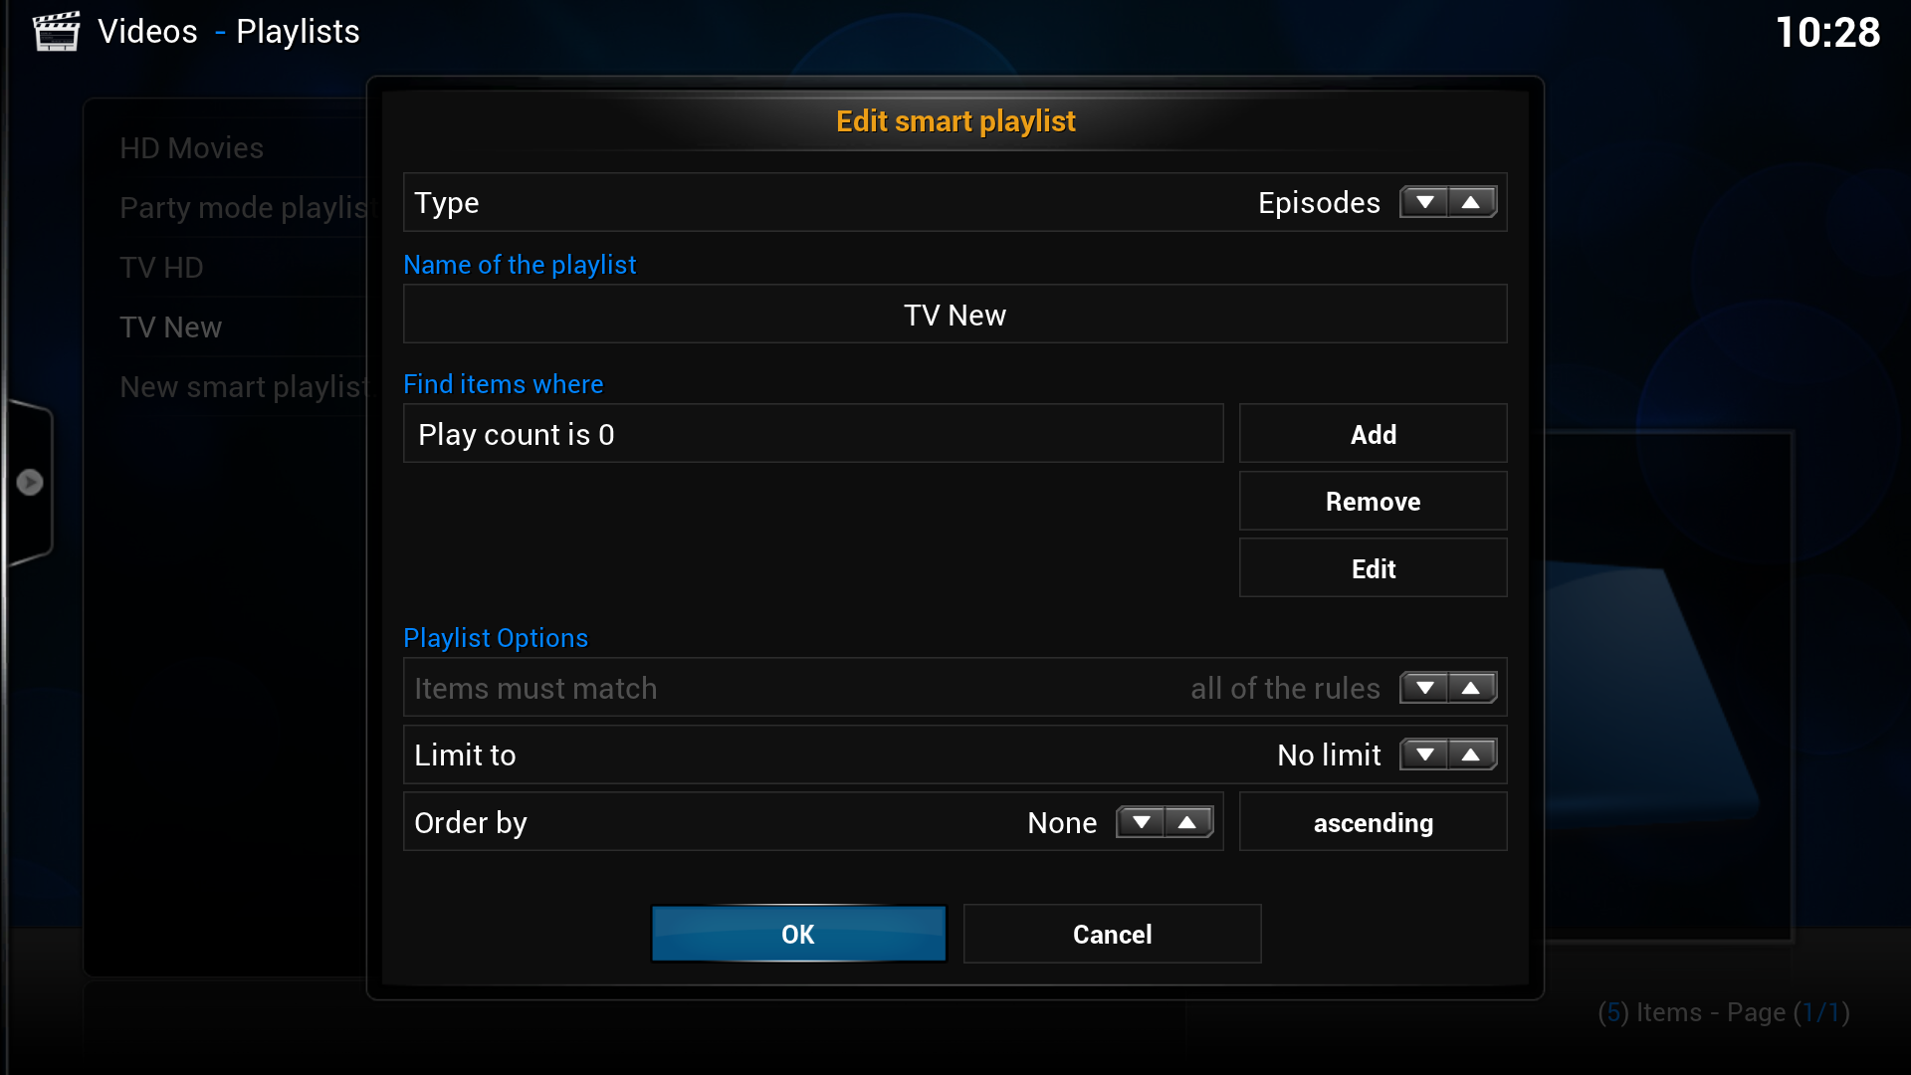

Result (of course: you can set own views here too!):  
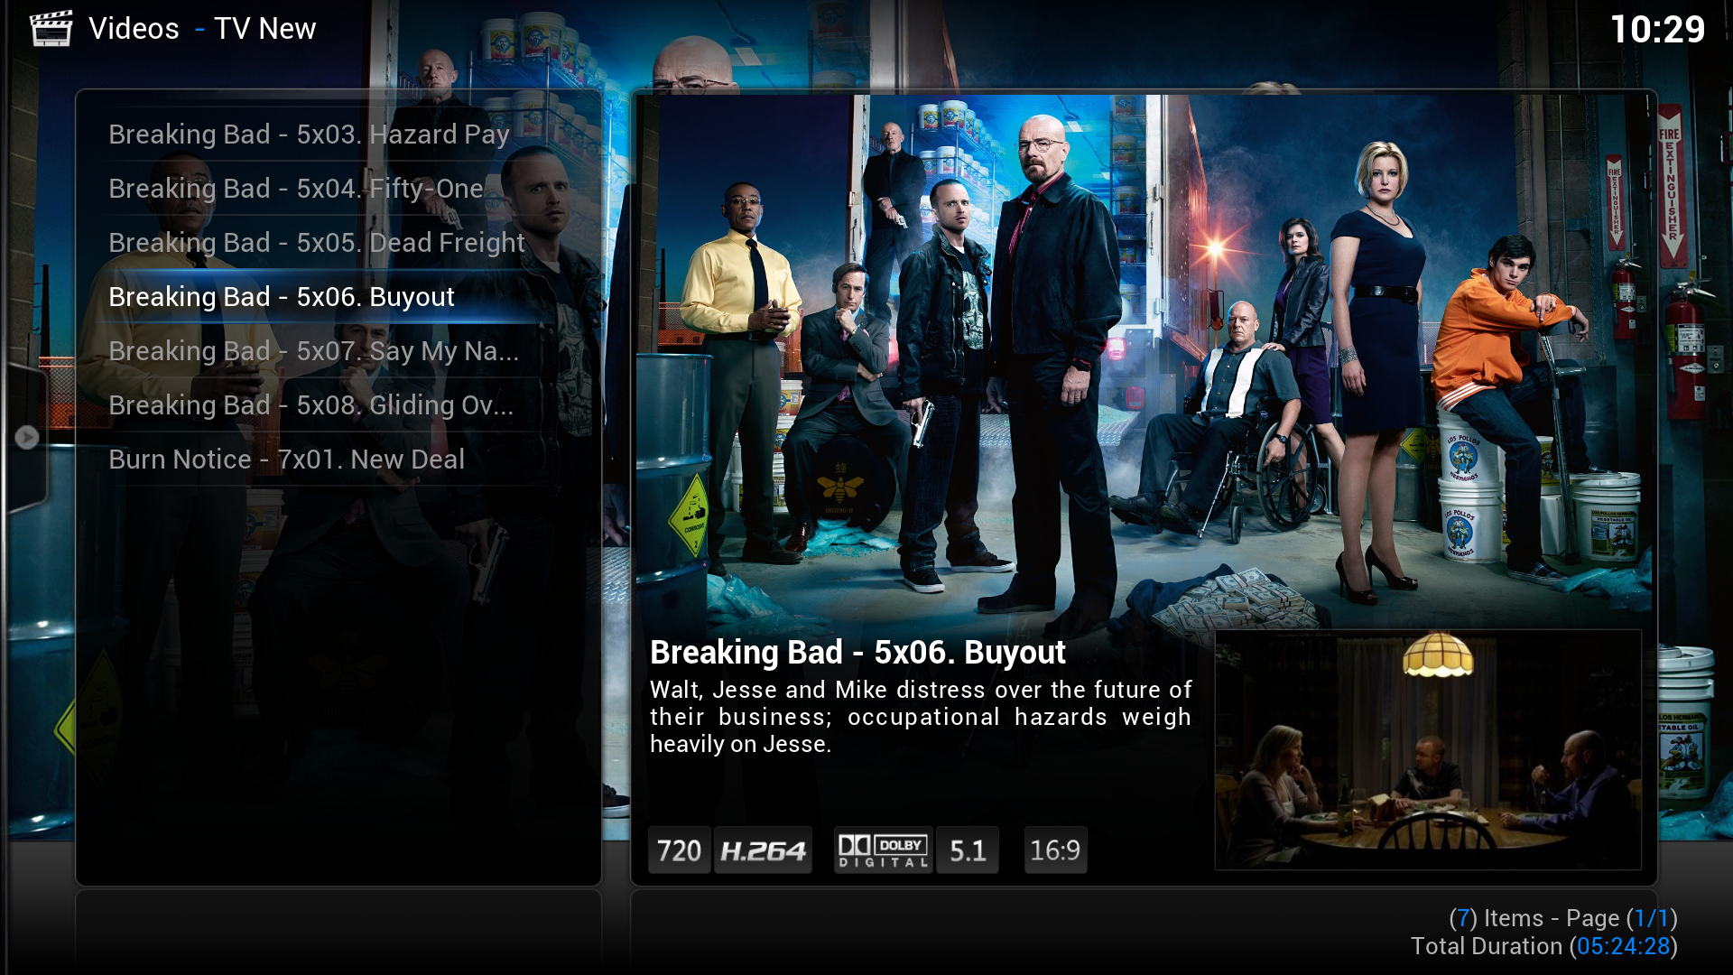

### The Context Menu

The context menu gives access to a host of different functions for BOXIK. I’ll give you some examples, to show you, that it is a powerful tool.

#### Accessing the current queue

BOXIK has a playlist of currently running items, called a “Queue”. This playlist behaves just like every other playlist – you can add items to it, you can save it, you can edit it, etc.

To access this playlist you have to have some items in it. So go down do you TV-Show section (or movie-section, for that matter) and mark any Show. Bring up the context menu (usually by pressing “c” on your keyboard) and click on “Queue item”. Now bring up the context menu again and you will find a new entry called “Now Playing…” – click this item to access the playlist of currently queued items:  
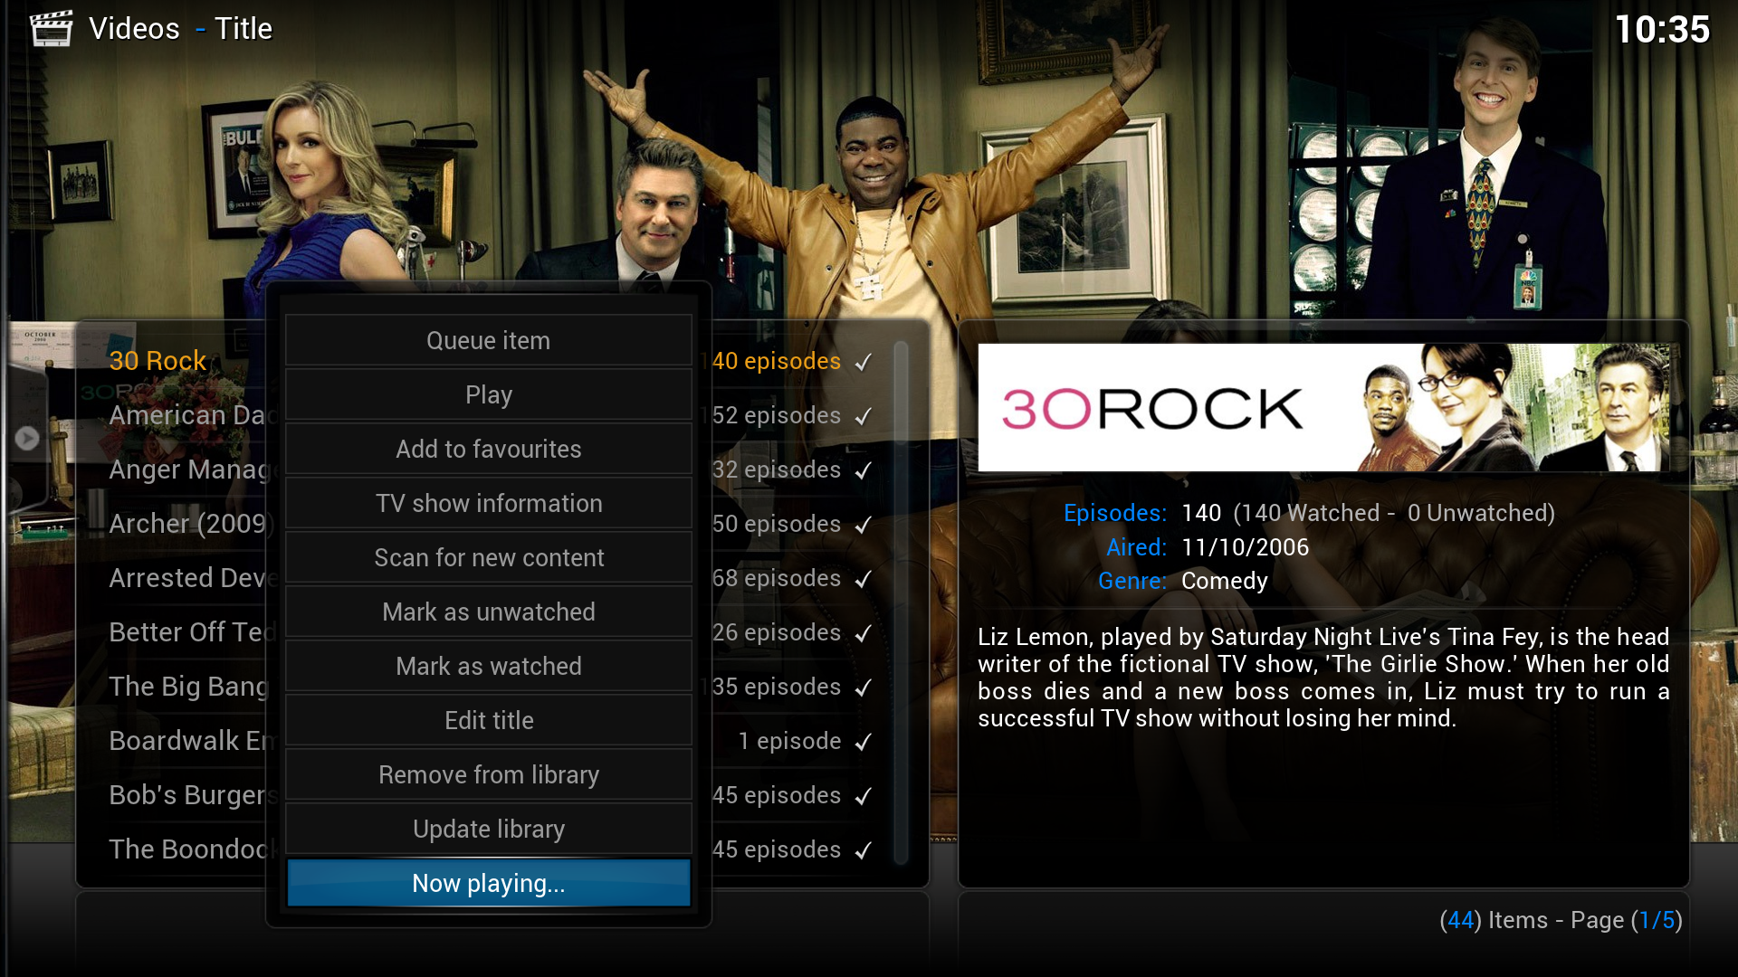

You can now interact with the playlist – you can for example save it, Shuffle the items (randomize the items) or repeat it: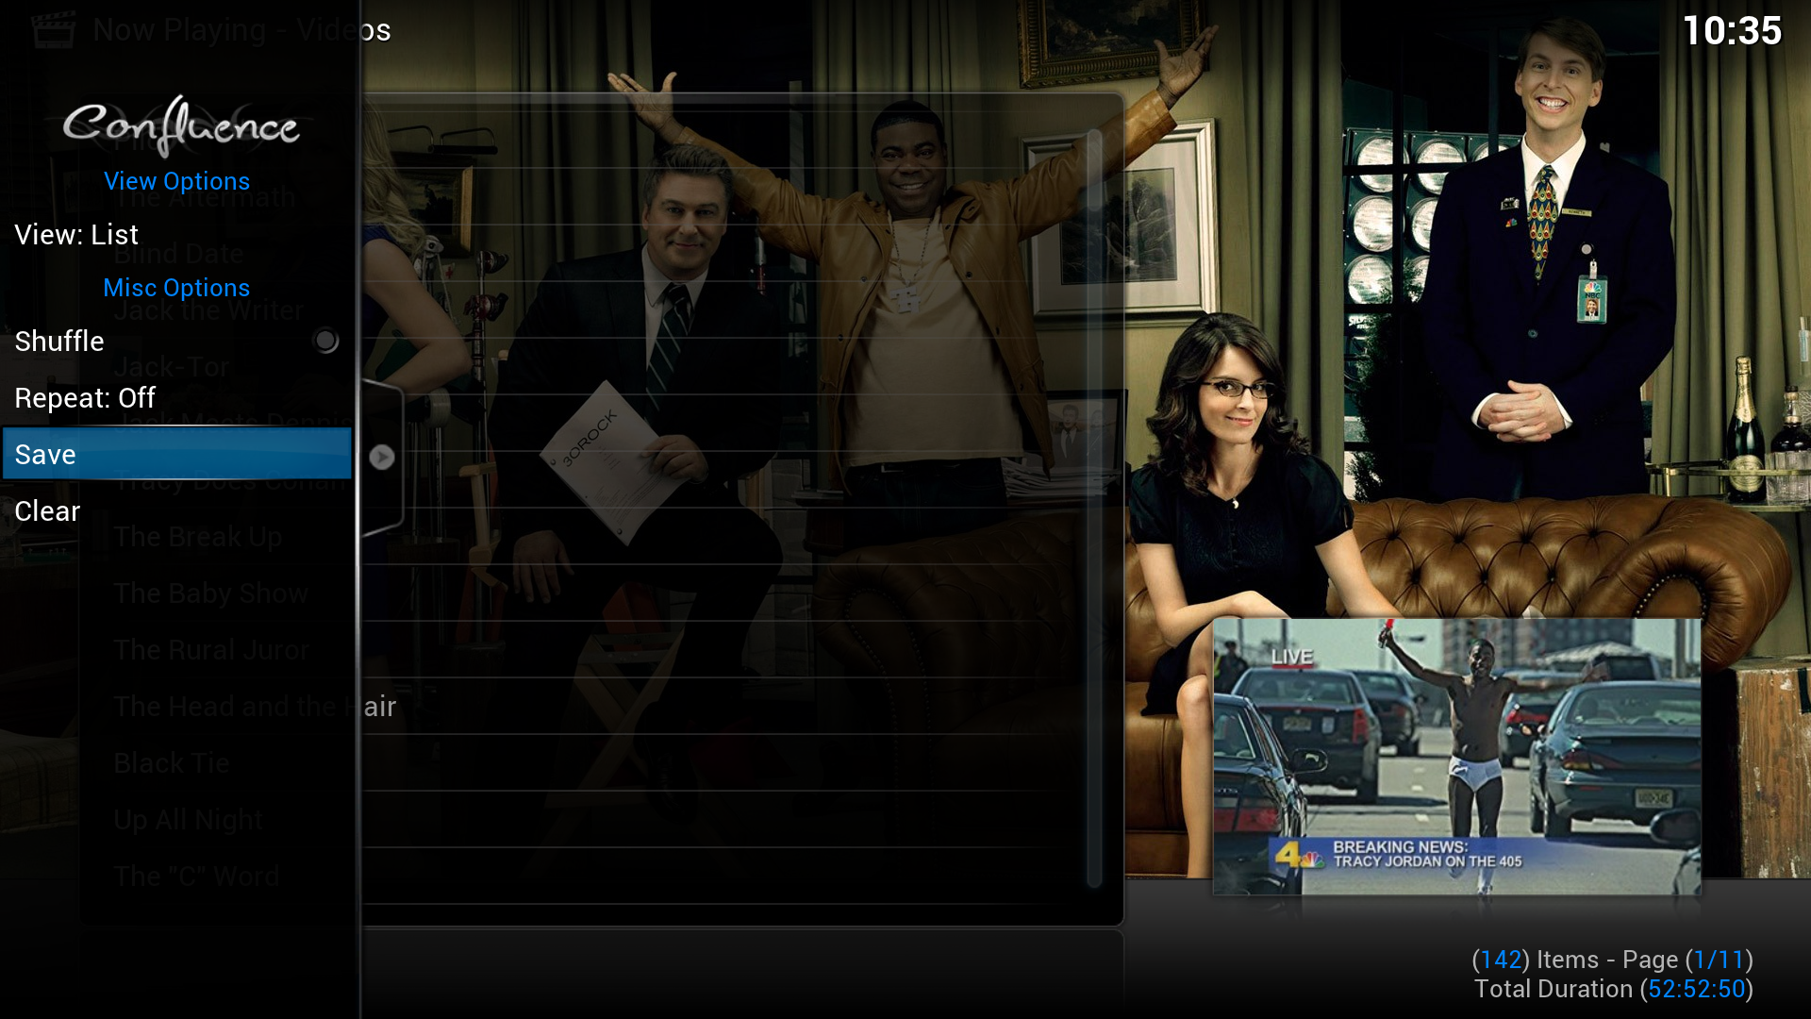

#### TV Show/Episode/Movie Information

Via the context menu you can also access more information on any given resource. You can for example get more information on the Writers, Directory, etc. of a specific movie. Here is an example:  
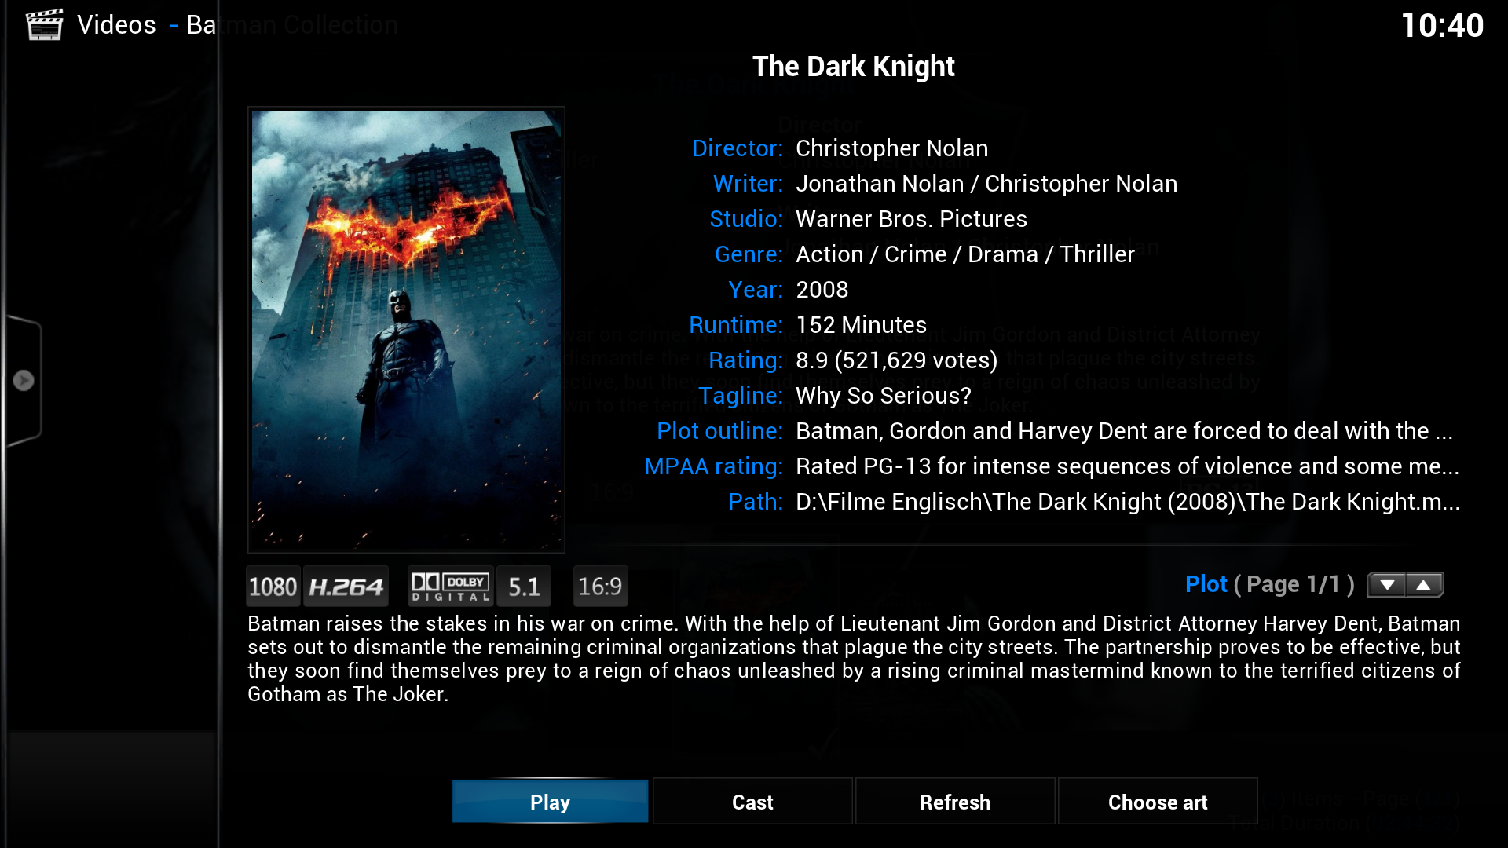

Different skins can have different options available. For example there are some skins which feature a “Trailer”-Option. This will automatically search for a trailer and play it. The standard skin does not include this feature however. To access this screen, just press “Episode Information”/”TV Show Information”/”Movie Information” (depending on the resource selected) in the context menu.

#### Favorites

In BOXIK you can also setup a special list of items: Your favorites. Your favorites can be all kind of resources – just bring up the context menu when you selected an item (really: any item – except for the home-screen items) and click on “Add to Favorites”. The item will be added to your Favorites-List. This list can be accessed via the home-menu.

#### The Shutdown Menu

There is another special menu in BOXIK which is called the “Shutdown Menu”. The Shutdown Menu can be used to exit BOXIK, shutdown the computer (hence the name), restart the computer, etc. Different skins have different Shutdown-Menus which also include different features. This is an example of the default shutdown menu included in the default skin (called Confluence):  
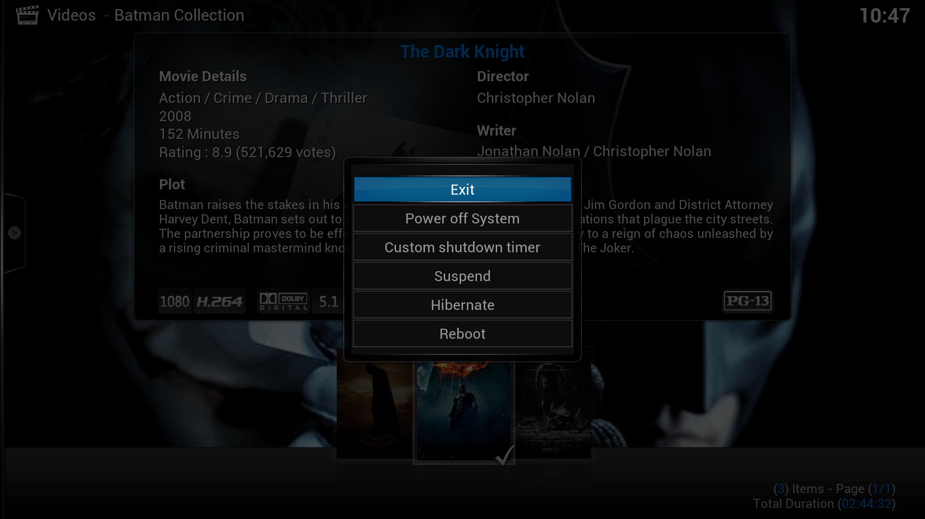

#### Link to TV Show

Sometimes you have movies which are based on a TV Show. BOXIK has a special handling for those movies – bring up the context menu while the specific movie is select and hit “Link to TV Show” – then select the TV Show it is based on. The movie will then show up in the season list of that TV Show:

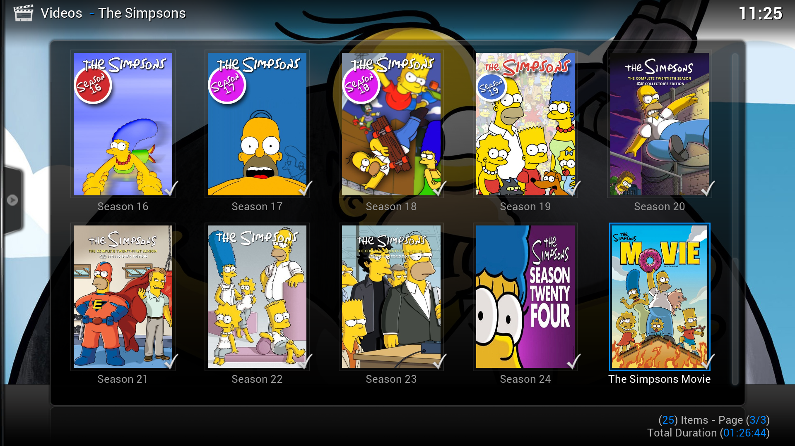

## Additional Settings

### Library Settings

Navigate back to the Home-Window (hit Backspace to get back) and open up the Settings-Menu. Open the “Video”-Tab and click on the Library-Tab. I recommend using “Automated Scan on Startup”, this way you make sure that every new file you add will be there after you restart your BOXIK. I will explain later how you can start the scan by yourself. Remember the “Clean Library”-Button – if you delete files out of the folders you specified under your Sources it still will show up in the library of BOXIK, even after you scanned for new content. To remove dead entries hit the button “Clean Library”, it will remove them.

Warning:   
You should be aware that cleaning your library may result in unexpected behavior. If your media-sources for example are located on an External Drive and you launch the cleaning while the drive is disconnected, your whole library will be erased! If the media somehow isn’t available, you are going to lose everything stored in the library.

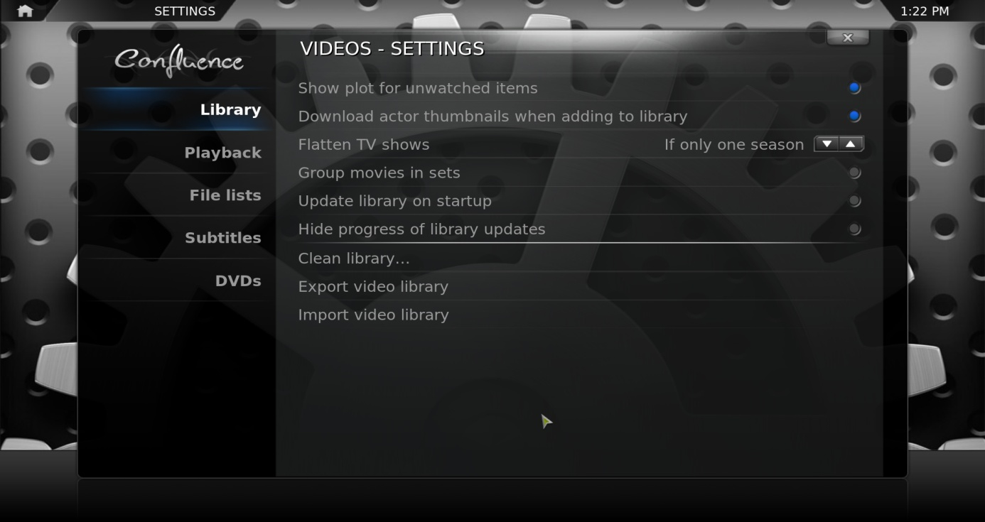

## Customization

### Skins

You can apply complete new skins to your BOXIK which will change the look and feel of BOXIK entirely. I am currently using the “Aeon Nox” skin, although you might prefer something else. To install a new skin, open up the “Appearance”-Settings. You will find an option “Skin” – click here to open the Skin-Selector. Click on the “More”-Button at the bottom of the selector. Choose the skin you want to try and it will download. After the download completes you will be asked to switch to the skin – choose what you like.

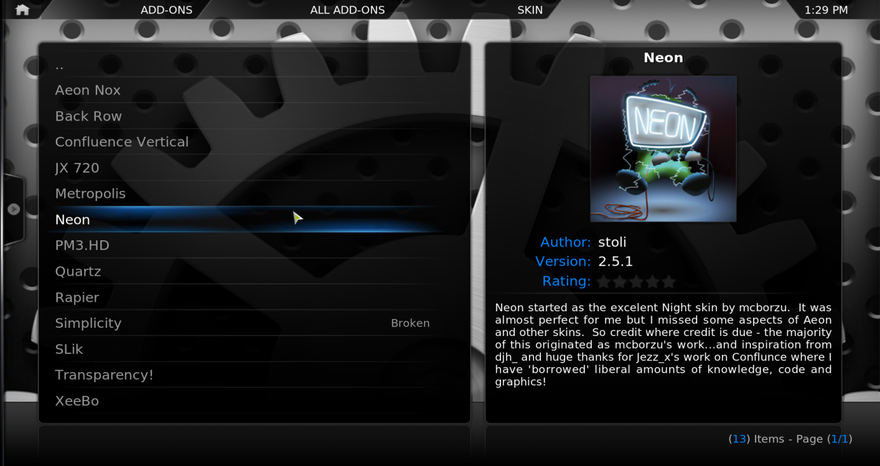

#### Skin Settings

A Skin can have a different set of settings which can be applied to your setup. You can access those settings usually via Settings 🡪 Skin. Here is an example for Aeon Nox:  
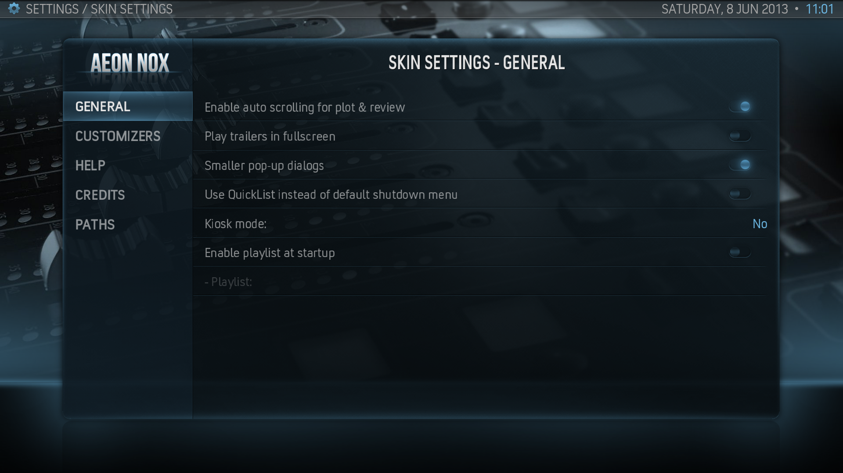  
You can usually customize the whole layout of the skin – including the buttons which are displayed in the home-screen. Play a little bit around with those settings to find out what they’re doing and see what you like best.

##### “Extras”-Skins

There are several skins with advanced features which can be applied to your TV-Library. As an example, your skin may support either TV-Show-Logos or TV-Show-Tunes. A logo should be self-explanatory – it is a title-image for the specified show. The Tunes will play as soon as you navigate to one of your show (e.g. If you have a show called 30 Rock and a proper tunes-file in the folder of 30 Rock, the tune will play as soon as you hit the “30 Rock”-entry in the library.

For both of those features most supported skins have built-in support and scripts in order to get the necessary stuff. Search for an option “Run logo script” and/or “Run tunes script” which will then download the necessary files in order to view the advanced features. You may have to apply these features in additional settings of your skin.

Bear in mind that both features generally require some “hacking” on the skin-developers end. If you have any problems with the scripts, please report them to the maker of these scripts. BOXIK by default does not have any support for those features built in.

There are a lot of possible features – a screen for upcoming TV Shows “built in”, Trailers, etc. – be sure to check out multiple skins to find out which feature you like best and what you want to use in your daily setup.

### Setup additional Add-ons

You can expand your BOXIK-Experience by installing Add-Ons/Plugins. Since BOXIK Dharma we have a repository installed from which we can choose additional Add-ons/Plugins. You can find this sub-section on the home-screen. Hit the “Add-On”-Section in BOXIK and choose “Get Add-ons” – browse and install what you like. Add-Ons can feature many different features – so be sure to check out what you might like and see if it fits your needs.